DAT102x Training experiment

# Loan Granting Binary Classification December 2016

## Azure ML experiment overview:

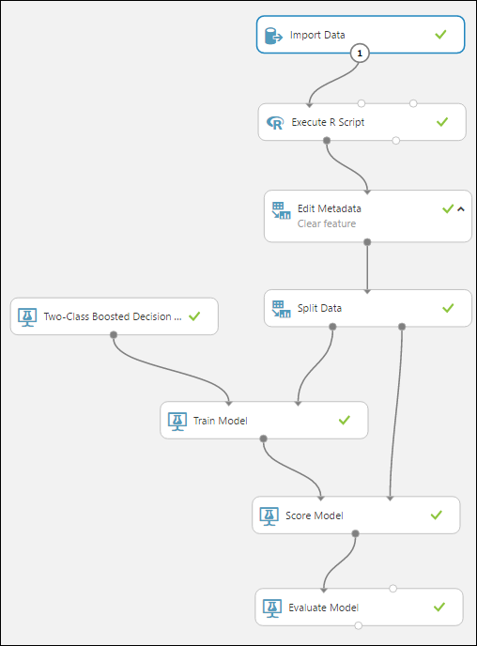

## Detailed view of all steps:

1. Import Data  
   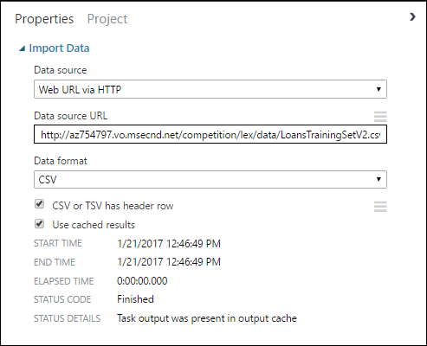
2. Execute R Script (see Dat102x.r)  
   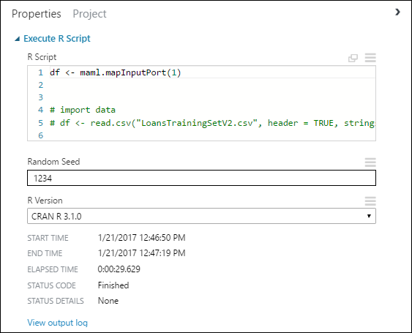
3. Edit Metadata  
   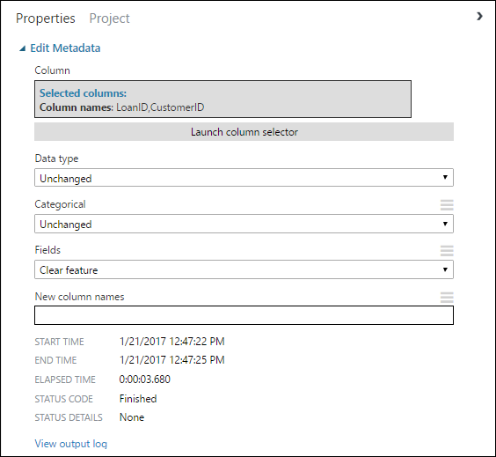
4. Split Data  
   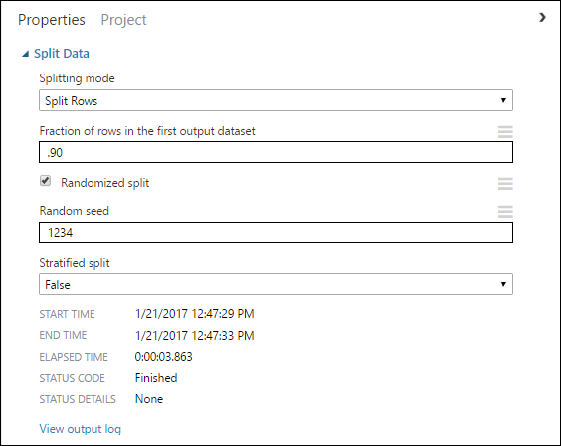
5. Train Model  
   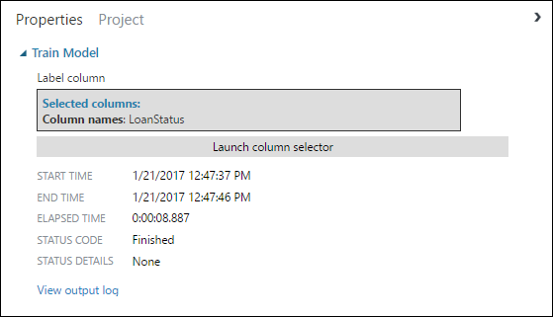
6. Two-Class Boosted Decision Tree  
   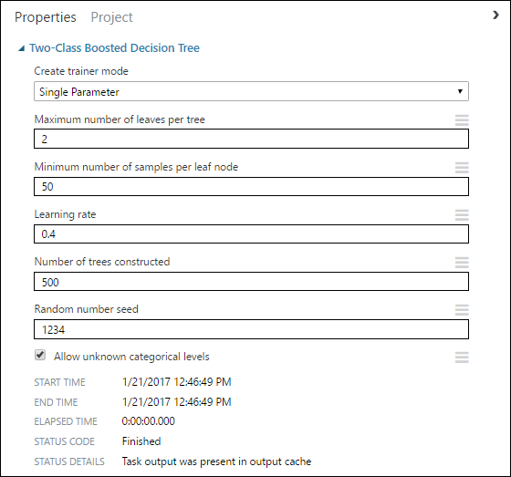
7. Score Model  
   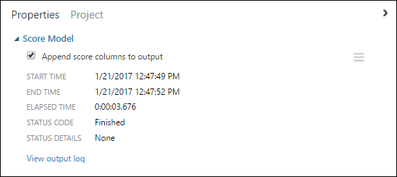
8. Evaluate Model  
   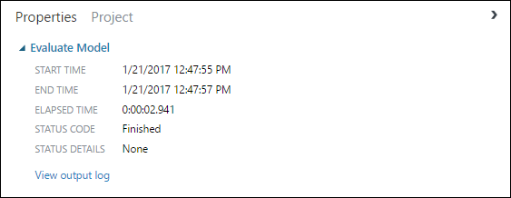

## Competition page and results:

<https://gallery.cortanaintelligence.com/Competition/1ad7a6df99794816b9bc071e27d46b10#leaderboardButton>

* 744 participants
* 13,734 submissions

